Electric Power Systems Research

Dear Dr. Derald,

Kindly find the attached revision of the paper entitled “Distance Protection Zone 3 Misoperation During System Wide Cascading Events: The Problem and a Survey of Solutions” which we are submitting for exclusive consideration for Electric Power Systems Research.

We agree with the comments of the reviewers’ and updated the paper accordingly. We have attached the response to the reviewers’ separately.

Finally, we hope you and the reviewers find the paper enjoyable as we found it during preparation, writing and proof reading.

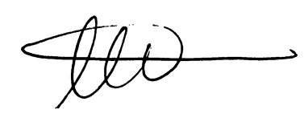

Ahmad Abdullah

Power System Design Engineer

Electric Power Engineers Inc.,

Austin, TX, 78738